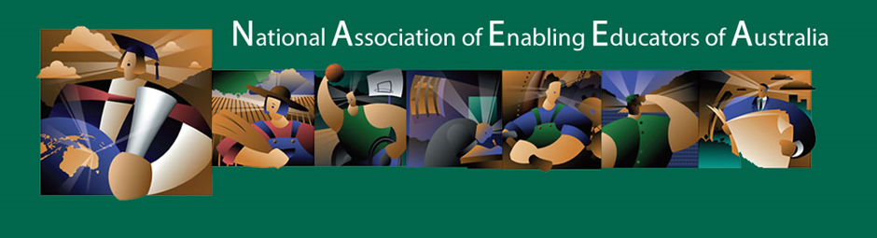

National Association of Enabling Educators Australia (NAEEA)
Annual General Meeting
President’s Report for 2018
Friday 22 March, 2019

In 2018, NAEEA comprised:
- 130 members
- 13 Executive members representing 9 institutions
  - University of Southern Queensland, University of Newcastle, UniSA. Charles Darwin University, Southern Cross University, Charles Sturt University, University of Wollongong , CQUniversity, Unitec Institute of Technology New Zealand (FABENZ Chair)
- 8 Special Interest Groups (SIGS)
  - Enabling Assessment
  - Enabling Curriculum
  - Mental Health
  - Research
  - Science, Technology, Engineering and Maths (STEM)
  - Culturally and Linguistically Diverse Students
  - Online Learning
  - Indigenous Students
Principal Activities
- Acknowledged the substantial contribution Rae Trewartha made in her role as Chair of FABENZ. 2018 was Rae’s final year as Chair of FABENZ. Maria Meredith and Sonia Fonua, both from the University of Auckland will co-chair FABENZ from 2019.
- Provided a letter of Appreciation to Professor Janet Taylor, Southern Cross University for hosting the 2017 NAEEA Conference
- Acknowledged the contribution ‘retiring’ colleagues have made to Enabling over a substantial period.
  - Professor Seamus Fagan (University of Newcastle)
  - David Bull (University of Southern Queensland)
  - Professor Janet Taylor (Southern Cross University)
- Created the ‘Defining Enabling Document to clarify enabling education so that we can:
  - Support and develop effective quality assurance that is recognised across the sector
  - Facilitate comparison between programs and encourage cross-institutional transfer
  - Assist in the clarification of funding protocols
  - Raise the public profile of the role of enabling in the higher education sector as a mechanism for access, social mobility and career transformation
- In an effort to make Enabling Education more visible in the sector, promote the its worth and strengthen our voice , the committee:
  - Embarked on a membership drive
  - Created and disseminated a promotional card
  - Funded the production of a promotional video
  - Developed an Infographic
- Signed a partnership agreement with FACE (Forum for Access and Continuing Education) Professor John Storan - FACE Chair | Director – Continuum: Centre for Widening Participation Policy Studies at the University of East London
- Supported the NAEEA Symposium hosted by the English Language and Foundation Studies Centre, University of Newcastle organised by Dr Anna Bennett and Dr Jo Hanley
  - Provided opportunity to celebrate our work as enabling educators
  - Confirmed the priorities the Executive had set for the year aligned with what members considered as priorities
  - Confirmed and cemented our belief that our institutions operate as partners not competitors in the Enabling space.
- Supported Dr Pranit Annand (University of Wollongong) plan for the combined EPHEA/NAEEA conference in Wollongong in 24-27 November
- Agreed to the establishment of a perpetual Eleanor Ramsay Award to be presented for best paper/best initiative at the NAEEA conference – first award at EPHEA/NAEEA in 2019
- Established the criteria for Expression of Interest to host NAEEA conference
- Voted to provide a $1000 contribution to the CEEHEE Writing Program in 2019
- Submitted responses to consultation papers, reviews and a call for expression of interest:
  - Response to consultation paper – Redistribution of Enabling Places
  - New distribution mechanism
  - Submission to the Review of the Australian Qualifications Framework (AQF)
  - Submission of EOI to support Labor’s commitment to boost equity and participation in Australia’s universities. The NAEEA Executive called for Enabling programs to have uncapped places, to remain free and entirely open access and to be situated within universities where there is proven expertise and capacity to offer pathways into undergraduate study. The request was also made for consistent institutional funding be assured to ensure that enabling programs and enabling outreach activities are well-resourced in terms of staffing and other essential costs and that enabling loading for universities be not tied to annual budgets or election cycles. The submission also included a request for funding to establish a national enabling provision and evaluation framework as a priority, alongside a quality framework and funding to facilitate benchmarking of enabling programs.
- Conducted the election of executive members
  - 5 positions – 4 existing members were re-elected
  - We thanked outgoing NAEEA executive members
    - Jennifer Stokes (UniSA)
    - Liz Smith (Charles Sturt University)
  - We welcomed new member – Sarah Hattam (UniSA)
Going forward – 2019 will see a major revamp of the NAEEA Website
- Continued drive to increase the association membership
- Continued commitment to advocating for Enabling

